25.10.4 Editors - Properties Editor - Physics Properties Tab - Dynamic Paint panel
Detailed table of content 1
Dynamic Paint 4
Type 4
Workflow 5
Workflow Paint simulation 5
Workflow Displace simulation 6
Workflow Weight simulation 6
Workflow Ocean simulation 8
Canvas - Settings subpanel 8
Add Canvas / Remove Canvas 8
Active Point Cache Index 8
Add Surface Slot 9
Remove Surface Slot 9
Format 9
Anti-Aliasing 9
Canvas - Surface subpanel 10
Surface Type 10
Canvas - Cache subpanel 13
Hints 14
Caches List 14
Add New Cache 15
Delete current Cache 15
Info string 15
Bake / Delete Bake 15
Calculate To Frame 15
Current Cache to Bake 15
Bake All Dynamics 15
Delete All Bakes 15
Update All To Frame 15
Canvas - Effects subpanel 15
Spread 16
Drip 16
Shrink 17
Canvas - Initial color subpanel 17
None 17
Color 17
UV Texture 17
Vertex Color 17
Canvas - Output subpanel 18
With Vertex Format 18
With Image Sequence format 18

Detailed table of content
Detailed table of content
Detailed table of content 1
Dynamic Paint 4
Type 4
Workflow 5
Workflow Paint simulation 5
Workflow Displace simulation 6
Workflow Weight simulation 6
Workflow Ocean simulation 7
Canvas - Settings subpanel 8
Add Canvas / Remove Canvas 8
Active Point Cache Index 8
Drag Handler 8
Search Field 8
Invert 9
Sort by Name 9
Add Surface Slot 9
Remove Surface Slot 9
Format 9
Vertex 9
Image Sequences 9
Resolution 9
Anti-Aliasing 9
Frame Start 9
End 9
Sub-steps 9
Canvas - Surface subpanel 10
Surface Type 10
Paint 10
Brush Collection 10
Scale Influence 10
Radius 10
Dissolve 10
Time 10
Slow 10
Dry 10
Time 10
Color 10
Slow 11
Displace 11
Max Displace 11
Displace Factor 11
Incremental 11
Brush Collection 11
Scale Influence 11
Radius 11
Dissolve 11
Time 11
Slow 11
Weight 11
Brush Collection 12
Scale Influence 12
Radius 12
Dissolve 12
Time 12
Slow 12
Waves 12
Open Borders 12
Timescale 12
Speed 12
Damping 13
Spring 13
Smoothness 13
Brush Collection 13
Scale Influence 13
Radius 13
Canvas - Cache subpanel 13
Hints 13
Caches List 14
Drag Handler 14
Search Field 14
Invert 14
Sort by Name 14
Add New Cache 14
Delete current Cache 14
Info string 15
Bake / Delete Bake 15
Calculate To Frame 15
Current Cache to Bake 15
Bake All Dynamics 15
Delete All Bakes 15
Update All To Frame 15
Canvas - Effects subpanel 15
Spread 15
Speed 16
Color 16
Drip 16
Velocity 16
Acceleration 16
Weights 16
Shrink 16
Speed 16
Canvas - Initial color subpanel 17
None 17
Color 17
Color 17
UV Texture 17
Texture 17
UV Map 17
Vertex Color 17
Canvas - Output subpanel 17
With Vertex Format 17
With surface type Paint 17
With surface type Weight 18
With Image Sequence format 18
With surface type Paint 18
Bake Image Sequence 18
Cache Path 18
Accept 18
Premultiply Alpha 18
Paintmaps 18
Name 18
Wetmaps 18
Name 18
With surface type Displace 19
Bake Image Sequence 19
Cache Path 19
Accept 19
Premultiply Alpha 19
Filename 19
Displace Type 19
Max Displace 19
With surface type Waves 19
Bake Image Sequence 19
Cache Path 19
Accept 19
UV Map 19
File Format 19
Premultiply Alpha 19
Filename 20
Wave Clamp 20

Dynamic Paint

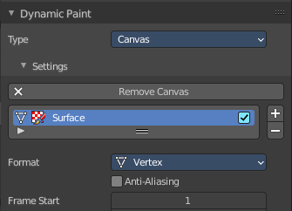
Dynamic paint is a modifier and physics system that allows to paint at the mesh surface of an object. You need an object that is set up as the canvas. And an object that is set up as the brush to create the required vertex colors, image sequences or displacement.
This combination makes many effects possible. For example footsteps in the snow, raindrops that make the ground wet, paint that sticks to walls, or objects that gradually freeze.

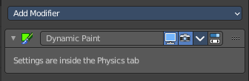
Creating a dynamic paint physics adds a modifier in the modifier tab. But the settings can just be adjusted from the physics tab.

Type
The Dynamic Paint modifier has two different types Canvas and Brush. And the panel content shows either the settings for the canvas or for the brush type.
Note! You can also enable brush and canvas simultaneously by add canvas and add brush. In that case same object’s “brush” does not influence its “canvas”, but can still interact with other objects in the scene.

Workflow

Workflow Paint simulation
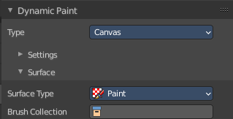
Create a grid object. Scale it a bit bigger. Add a SDS modifier with type simple.
Add a dynamic paint physics. And set the type to Canvas. In the surface section set the type to Waves.
Create a sphere.
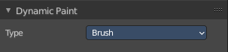
Add a dynamic paint physics. And set the type to Brush.

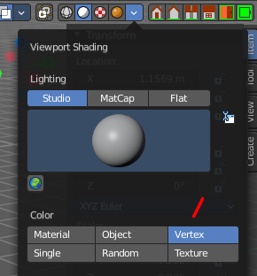
Paint is a vertex painting effect. So in the viewport shading enable vertex color to see the paint effect.

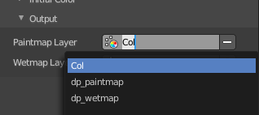
For the canvas object go to the end of the list, remove both, the paintmap layer and the wetmap layer, and add a new paintmap layer.

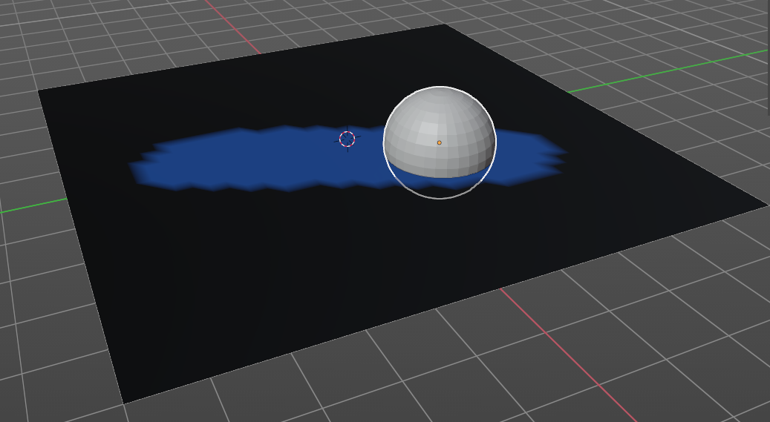
The paint effect is a dynamic and so an animated effect. And so you need to play the animation. Now, with the animation playing, move the sphere into the grid object. You will see the surface of the grid object react to the contact with the sphere.
You can of course also set keyframes to record the motion of the brush sphere.

Workflow Displace simulation
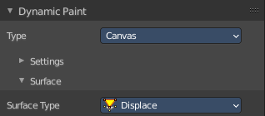
Create a grid object. Scale it a bit bigger. Add a SDS modifier with type simple.
Add a dynamic paint physics. And set the type to Canvas. In the surface section set the type to Waves.
Create a sphere.
Add a dynamic paint physics. And set the type to Brush.
The paint effect is a dynamic and so an animated effect. And so you need to play the animation. Now, with the animation playing, move the sphere into the grid object. You will see the surface of the grid object react to the contact with the sphere.

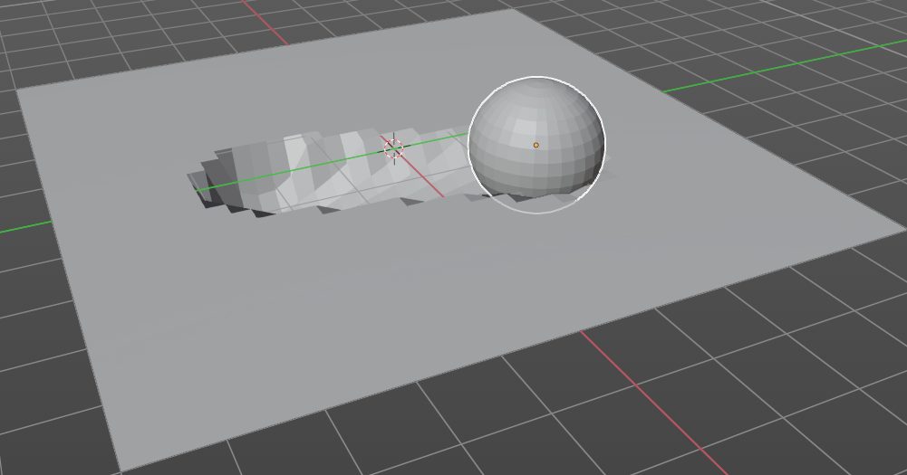
You can of course also set keyframes to record the motion of the brush sphere.

Workflow Weight simulation
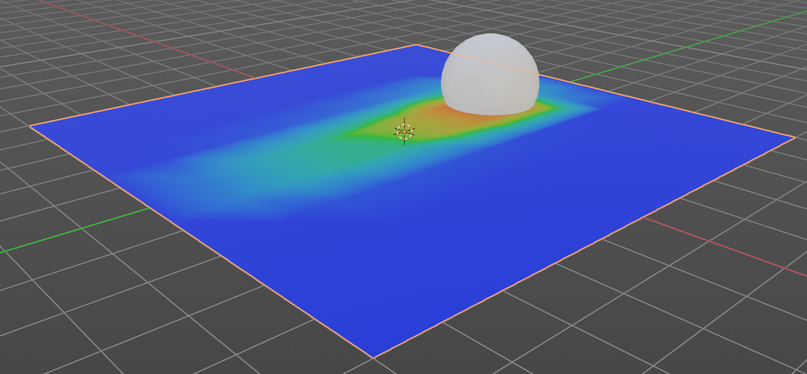
The workflow is similar to the Paint workflow. But the result cannot be visualized. The image at the right shows the in between step across paint. And you need to bake the result to use it.

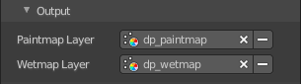
Node setup to visualize the result with the Paint method. You need to be in viewport shading method Material Preview. And in the Output of the Dynamic Paint the wetmap layer needs to be activated so that it shows up in the vertex color node.
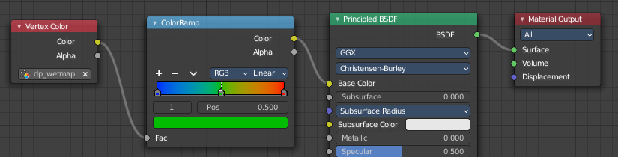

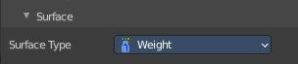
When done switch to surface type Weight.

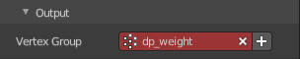
In the Output subpanel of Dynamic Paint activate the Vertex Group. This is done by clicking at the +button behind the vertex group.
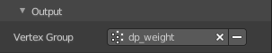
Bake the result.
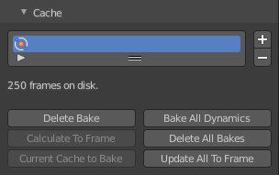

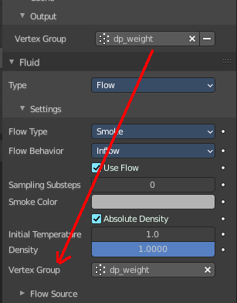
The vertex group output from dynamic paint can now be used in quick smoke for example, to determine where smoke should appear.

Workflow Ocean simulation
Create a grid object. Scale it a bit bigger. Add a SDS modifier with type simple.
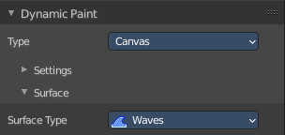
Add a dynamic paint physics. And set the type to Canvas. In the surface section set the type to Waves.

Create a sphere.
Add a dynamic paint physics. And set the type to Brush.

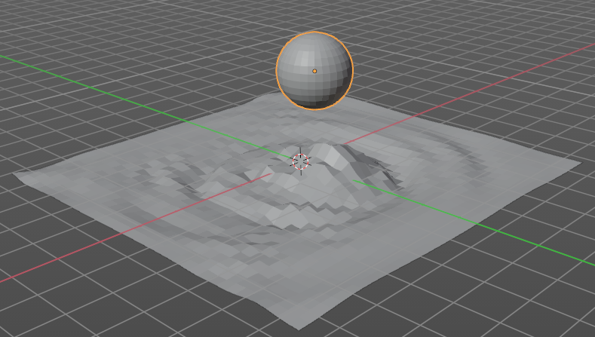
The paint effect is a dynamic and so an animated effect. And so you need to play the animation. Now, with the animation playing, move the sphere into the grid object. You will see the surface of the grid object react to the contact with the sphere.
You can of course also set keyframes to record the motion of the brush sphere.

Canvas - Settings subpanel

The Canvas type makes object receive paint from Dynamic Paint brushes.
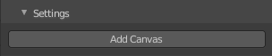

Add Canvas / Remove Canvas
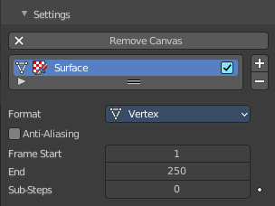
Add a canvas. When a canvas is added the button turns into the remove canvas button.

Active Point Cache Index
A list of the available point caches. You can add more than one surface here. The type of this surface can be changed in the surfaces sub tab then. But just one surface can be the active one.
Double clicking at the name allows to rename the surface point cache.
Is Active allows you to turn off the surface point cache.

Drag Handler
The two vertical lines at the end is a handler with which you can expand the list.

Search Field

You can expand a search field at the bottom of the list. Type in your term and hit enter to filter for your term.

Invert
Exclude the search term instead of searching for it.

Sort by Name
Sort the List by name.

Add Surface Slot
Adds a surface slot

Remove Surface Slot
Removes the selected surface slot.

Format
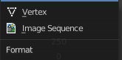
Each surface has a certain format and type. Format determines how data is stored and outputted.

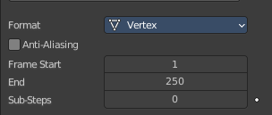
Vertex
Dynamic Paint operates directly on mesh vertex data. Results are stored by point cache and can be displayed in viewport. However, using vertex level also requires a highly subdivided mesh to work.

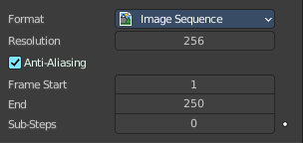
Image Sequences
Dynamic Paint generates UV wrapped image files of defined resolution as output.

Resolution
Image Sequence format. The output resolution of the single images.

Anti-Aliasing
Use Anti-Aliasing to smooth paint edges. The anitaliasing is using a 5× multi sampling method.

Frame Start
The start frame of the surface processing.

End
The end frame of the surface processing.

Sub-steps
Sub-steps are extra samples between frames. They are usually required when there is a very fast brush.

Canvas - Surface subpanel

Surface Type
Each surface has a “type” that defines what surface is used for. Dependent of the chosen surface type you will see other settings.

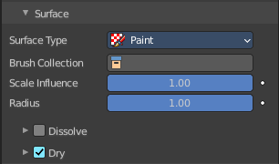
Paint
Paint outputs color and wetness values. In case of vertex surfaces, results are outputted as vertex colors.
A wetmap is a black-and-white output that visualizes paint wetness. White being maximum wetness, black being completely dry. It is usually used as mask for rendering. Some “paint effects” affect wet paint only.

Brush Collection
Define a specific collection to pick brush objects from.

Scale Influence
The influence the brush objects have on this surface.

Radius
Adjust radius of proximity brushes or particles for this surface.

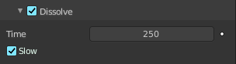
Dissolve
Make surface changes disappear over time.

Time
Approximately in how many frames the dissolve should happen.

Slow
Use logarithmic dissolve. This makes high values to fade faster than low values.

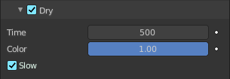
Dry
Make surface wetness dry over time. Completely disable drying can be used for indefinitely spreading paint.

Time
Approximately in how many frames the dry should happen.

Color
Define the wetness level when paint colors start to shift to surface “background”. Lower values can be useful to prevent spreading paint from becoming transparent as it dries, while higher values give better results in general.

Slow
Use logarithmic dissolve. This makes high values to fade faster than low values.

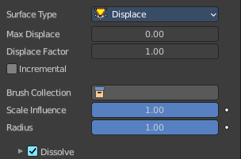
Displace
Outputs intersection depth from brush objects. It deforms the mesh.
Tip! If the displace output seems too rough it usually helps to add a Smooth Modifier after Dynamic Paint in the modifier stack.

Max Displace
The maximum level of intersection depth, larger values will be clamped to this value.

Displace Factor
The multiplier for the intersection depth. You can use it to adjust final displace strength or use negative values to paint bumps.

Incremental
A new displace is added cumulatively on top of an existing displace.

Brush Collection
Define a specific collection to pick brush objects from.

Scale Influence
The influence the brush objects have on this surface.

Radius
Adjust radius of proximity brushes or particles for this surface.

Dissolve
Make surface changes disappear over time.

Time
Approximately in how many frames the dissolve should happen.

Slow
Use logarithmic dissolve. This makes high values to fade faster than low values.

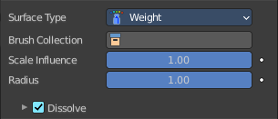
Weight
This special surface type is only available for vertex format output. It outputs vertex weight groups that can be used by other Blender modifiers and tools.
Tip! It is usually preferred to use “proximity” based brushes for weight surfaces to allow smooth falloff between weight values.
It requires a material to display the result.

Brush Collection
Define a specific collection to pick brush objects from.

Scale Influence
The influence the brush objects have on this surface.

Radius
Adjust radius of proximity brushes or particles for this surface.

Dissolve
Make surface changes disappear over time.

Time
Approximately in how many frames the dissolve should happen.

Slow
Use logarithmic dissolve. This makes high values to fade faster than low values.

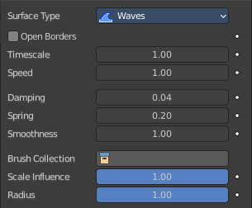
Waves
This surface type produces simulated wave motion. Like displace, wave surface also uses brush intersection depth to define brush strength.
Tip! In some cases the wave motion gets very unstable around brush. It usually helps to reduce wave speed, brush “wave factor” or even the resolution of mesh/surface.

Open Borders
Allows waves to pass through mesh “edges” instead of reflecting from them.

Timescale
Directly adjusts simulation speed without affecting simulation outcome. Lower values make simulation go slower and otherwise.

Speed
Affects how fast waves travel on the surface. This setting is also corresponds to the size of the simulation. Half the speed equals surface double as large.

Damping
Reduces the wave strength over time. Basically adjusts how fast wave disappears.

Spring
Adjusts the force that pulls water back to “zero level”.

Smoothness
Limit maximum steepness of wave slope between simulation points. Higher values results in smoother waves and higher calculation time.

Brush Collection
Define a specific collection to pick brush objects from.

Scale Influence
The influence the brush objects have on this surface.

Radius
Adjust radius of proximity brushes or particles for this surface.

Canvas - Cache subpanel

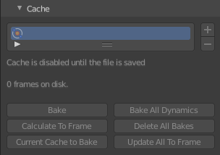
Vertex format only. For image sequence type the caching is done in the output panel.
The canvas simulation can be cached in memory or stored on a drive. This improves real-time response and avoids unnecessary recalculation of particles. But creates also big files.
The canvas system uses a unified system for caching and baking (together with Cloth, Soft Body and Emitter particle).
Important! The file needs to be saved after baking. When the file is not saved then some options are not available.
Important! The canvas settings becomes unavailable once the particle cache is baked. You need to remove the bake when you want to change the settings.

Hints
The simulation is only calculated for positive frames in between the Start and End frames of the Cache panel, whether you bake or not. So if you want a simulation that is longer than the default frame range, you have to change the End frame.
When an animation is played, each physics system writes each frame to the cache. Note that for the cache to fill up, one has to start the playback before or on the frame that the simulation starts.
The cache is cleared automatically on changes. But not on all changes, so it may be necessary to free it manually. For example if you change a force field.
The system is protected against changes after baking. If for example the mesh changes the simulation is not calculated anew.
The bake result can be cleared by clicking on the Free Bake button in the simulation cache settings.
A simulation can only be edited in Particle Edit Mode when it has been baked in memory. And cannot be edited if the Disk Cache is used.
If you are not allowed to write to the required sub directory caching will not happen. For example if your blend-file path is very long and your operating system has a limit on the path length that is supported.
Be careful with the sequence of modifiers in the modifier stack. You may have a different number of faces in the 3D Viewport and for rendering (For example when using subdivision surface). Then the rendered result may be very different from what you see in the 3D Viewport.

Caches List

The list of available caches. The caches have no name by default. Double click to add a name.
You can store and manage multiple caches at once for the same physics object. The active cache is the one that gets used.

Drag Handler
The two vertical lines at the end is a handler with which you can expand the list.

Search Field
You can expand a search field at the bottom of the list. Type in your term and hit enter to filter for your term.

Invert
Exclude the search term instead of searching for it.

Sort by Name
Sort the List by name.

Add New Cache
Add a new cache.

Delete current Cache
Deletes the selected cache.

Info string
An info string. Gives different messages, dependent of the status.


Bake / Delete Bake
Start baking. Once you have baked the cache the button turns into a Delete bake button. And allows you to remove the bake.

The baking progress can be seen in the footer. You need to be in Object Mode to bake.

Calculate To Frame
Bake only up to the current frame. Limited by End frame set in the cache settings.

Current Cache to Bake
Store any temporarily cached simulation data as a bake. Note that playing the animation will try to simulate any visible physics simulations. Depending on the physics type, this data may be temporarily cached. Normally such temporary caches are cleared when an object or setting is modified, but converting it to a bake will “save” it.

Bake All Dynamics
Bake all physics systems in the scene, even those of different types. Useful for baking complex setups involving interactions between different physics types.

Delete All Bakes
Free bakes of all physics systems in the scene, even those of different types.

Update All To Frame
Bake all physics systems in the scene to the current frame.

Canvas - Effects subpanel

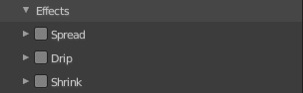
Surface Type Paint only. It generates animated movement on canvas surface.
For spread and drip effects, only “wet paint” is affected, so as the paint dries, movement becomes slower until it stops.

Spread
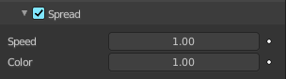
Paint slowly spreads to surrounding points eventually filling all connected areas.

Speed
How fast the spread effect moves on the canvas surface.

Color
How fast the colors get mixed within wet paint.

Drip
Paint moves in specific direction specified by Blender force fields, gravity and velocity with user-defined influences.

Velocity
How much surface velocity affect dripping.

Acceleration
How much surface acceleration affects dripping.

Weights
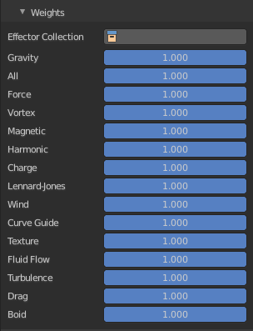
The dripping is influenced by physical forces. This panel allows you to adjust the amount of the single effector forces.
Effector collection allows you to limit the forces to a collection only.

Shrink
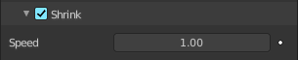
Painted area slowly shrinks until disappears completely.

Speed
How fast shrink effects move on the canvas surface.

Canvas - Initial color subpanel

Surface Type Paint only. Allows you to define the initial color of the canvas.

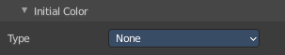
None
No initial color is used.

Color
Define an initial color.

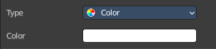
Color
Clicking at the color field opens a color picker where you can choose a color.

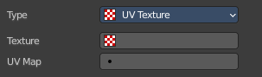
UV Texture
Use a UV texture as an initial color.

Texture
The texture to use. The texture that is meant here is not an image texture. But a created one. This can be done in the Texture tab.

UV Map
The UV map of the mesh. Usually you will just have one UV map available. But a mesh can have several ones.

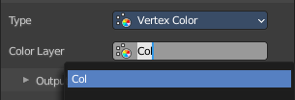
Vertex Color
Set an initial vertex color. You need to have a vertex color at the mesh. Then choose it here.
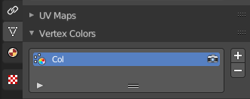
To create a vertex color layer go to the Object data properties to the Vertex color panel, and add a new one. Or simply enter the vertex paint mode and paint at least one vertice with a vertex color. Then a vertex color layer gets created.

Canvas - Output subpanel

With Vertex Format

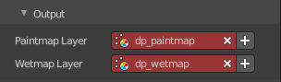
With surface type Paint
The Paintmap Layer dp_paintmap and Wetmap Layer dp_wetmap map types are vertex colors.
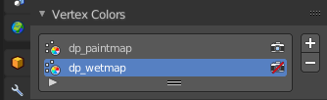
Red means this map type is deactivated. To activate the layers click at the + button at the right.
Once activated they can be found in the Vertex colors panel in the Object Data tab.

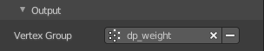
With surface type Weight
The Vertex Group dp_dp_weight is a vertex group.
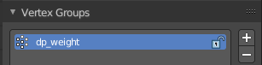
Red means this map type is deactivated. To activate the layers click at the + button at the right.
Once activated it can be found in the Vertex Group panel in the Object Data tab.

With Image Sequence format

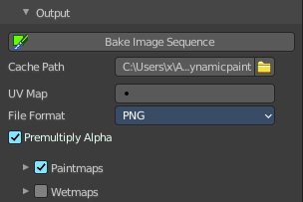
With surface type Paint

Bake Image Sequence
Bake the image sequence to file.

Cache Path
The path where the cache images are stored.

Accept
Open a file browser to choose another cache directory.

Premultiply Alpha
Multiply color by alpha.

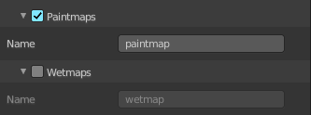
Paintmaps
Use paintmaps.

Name
The name of the paintmap to use.

Wetmaps
Use wetmaps

Name
The name of the wetmap to use.

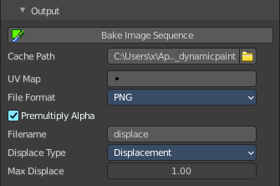
With surface type Displace

Bake Image Sequence
Bake the image sequence to file.

Cache Path
The path where the cache images are stored.

Accept
Open a file browser to choose another cache directory.

Premultiply Alpha
Multiply color by alpha.

Filename
The name that is used to save the output from this surface.

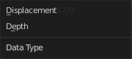
Displace Type
What displace type to use.

Max Displace
Maximum level of depth intersection in object space. Use 0.0 to disable it.

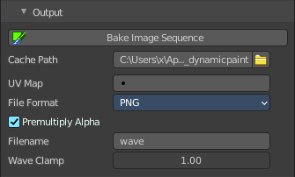
With surface type Waves

Bake Image Sequence
Bake the image sequence to file.

Cache Path
The path where the cache images are stored.

Accept
Open a file browser to choose another cache directory.

UV Map
UU map name to use. Leave empty when you don't work with UV maps.

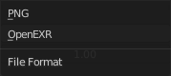
File Format
Save the images either with Open EXR or with PNG file format.

Premultiply Alpha
Multiply color by alpha.

Filename
The name that is used to save the output from this surface.

Wave Clamp
Maximum level of depth intersection in object space. Use 0.0 to disable it.

